Commercial Property for Sale
197 Bullitt Ave, S.E. &
502 Williamson Road, S.E.
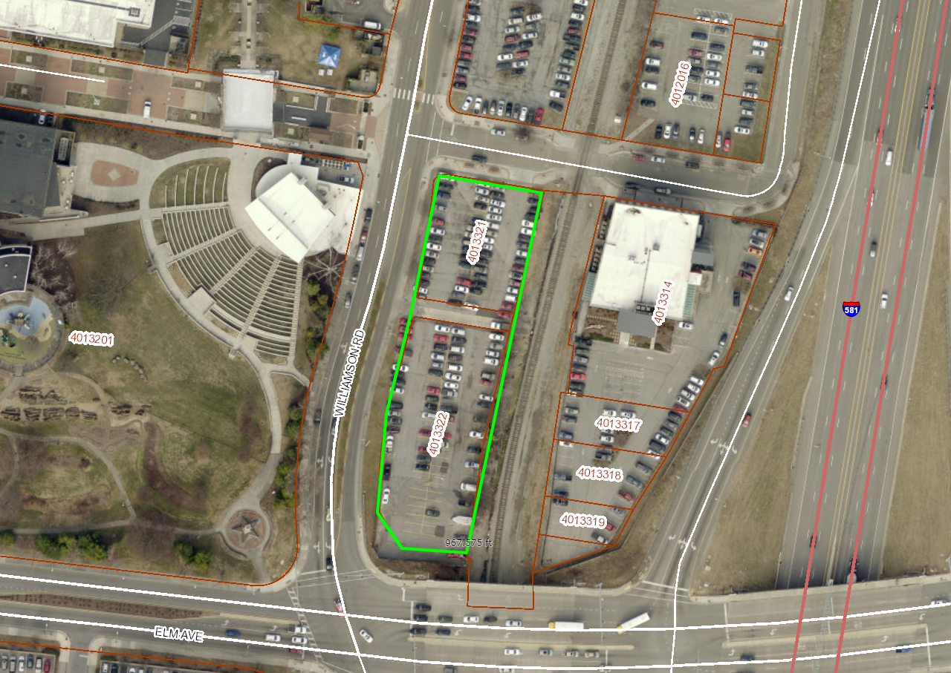
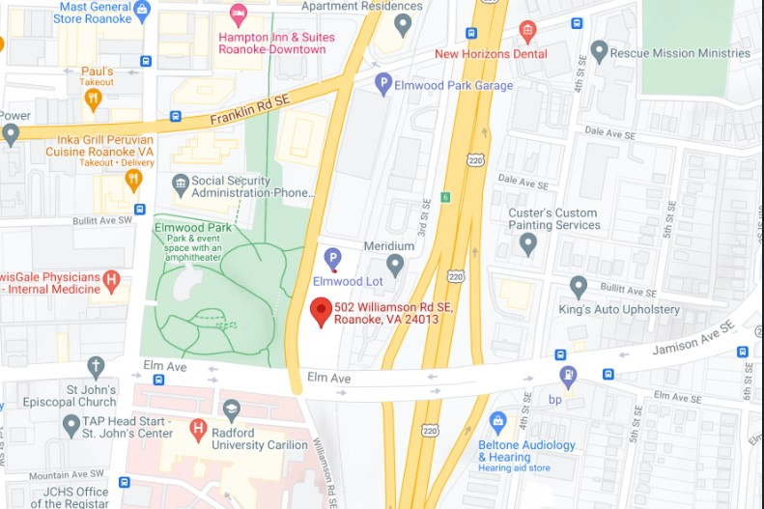

This site includes two parcels located at 197 Bullitt Avenue, S.E. and 502 Williamson Rd., S.E. and consists of approximately, 0.88 acres. The Tax Map Numbers associated with these parcel are 4013321 and 4013322. Their combined assessed value is $1,310,800.00.

Immediately adjacent to Elmwood Park and situated just blocks away from the Historic Farmers’ Market, the Market Building, and Center in the Square, as well as the Taubman Museum of Art, this site is highly visible from Interstate 581 and less than a quarter-mile from I-581 interchange.

For complete property details, please follow the link provided below to the City of Roanoke’s GIS system and use the Search/Query function by entering the tax map numbers.

GIS link: http://gisre.roanokeva.gov/

Our GIS system also displays Program Incentives so please follow that link for a more comprehensive listing of potential incentives.

This property, located in Enterprise Zone One A, may be eligible for the following Incentives:

- Fire, Water and Sewer Hookup Grants
- Building Permit and Comprehensive Development Review Fee Rebates
- Job Creation Grant
- Real Property Investment Grants

Proposals for the property must contain the following elements:

- Identification of the property, and any adjacent properties, involved in your development, as well as the intention to purchase or lease the parcel(s).
- Concept plan outlining the intended development use, including: location and size of any buildings, number of units, and a timeline for the completion of the project.
- Description of the qualifications and experience of the proposer/developer.
- Business Plan and Financial Plan for the project.
- Proposed offer amount for the property.

Proposals will be reviewed and evaluated for compatibility to the City of Roanoke’s Comprehensive Plan and Neighborhood Plan. The proposer will be contacted after sufficient time for staff review.

Offers must be received by January 14, 2022

Please submit your written proposal to:

Marc Nelson, Director
Department of Economic Development
117 Church Avenue, SW
Roanoke, VA 24011

Or by email to: econdevl@roanokeva.gov

For more information please contact the Department of Economic Development at 540-853-2715.

CITY OF ROANOKE ECONOMIC DEVELOPMENT DEPARTMENT SURPLUS PROPERTY SALE PROPOSAL

PROPERTY ADDRESS: TAX NUMBER:

DATE: APPLICANT/CONTACT PERSON:

FULL NAME (As to be stated on Deed):

HOME ADDRESS (or) PRINCIPAL OFFICE:
(Physical addresses only. No Post Office Boxes)

CITY: STATE: ZIP:

DAYTIME PHONE:

☐ | CORPORATION | ☐ | INDIVIDUAL(S)
☐ | LIMITED PARTNERSHIP | ☐ | JOINT TENANTS
☐ | LIMITED LIABILITY COMPANY | ☐ | TENANTS IN COMMON
☐ | PARTNERSHIP | ☐ | SOLE PROPRIETORSHIP

TOTAL BID AMOUNT:
(Must be expressed in whole dollar amounts)

PROPOSED USE (please include additional pages, if necessary):

I hereby certify that I have been provided with and have read the announcement of sale for the above-referenced property and submit this proposal in accordance with all provisions of the said announcement.

Signature

